13 May 2020

International trade price indices development in the Q1 2020

In the Q1 2020, compared to the Q4 2019, export prices decreased by 0.3% and import prices by 1.0%. The terms of trade reached the value of 100.7%. In the year-on-year (y-o-y) comparison, export prices dropped by 1.4%, import prices decreased by 1.7%, and the terms of trade reached the value of 100.3% in the Q1 2020.

# Quarter-on-quarter comparison

Export prices in the Q1 2020, compared to the Q4 2019, declined by 0.3%, quarter-on-quarter (q-o-q). The deepest decline was recorded for prices of 'mineral fuels, lubricants and related materials' (−7.9%), 'crude materials, inedible, except fuels' (−1.2%) and prices of both 'chemicals and related products’ and prices of 'manufactured goods classified chiefly by material' decreased the same (−0.9%). Prices of 'food and live animals' increased by 1.7% and prices of 'miscellaneous manufactured articles' by 0.5%.

Import prices in the Q1 2020, compared to the Q4 2019, decreased by 1.0%, q-o-q. The deepest decrease of prices was among 'mineral fuels, lubricants and related materials' (−9.1%), 'crude materials, inedible, except fuels' (−3.0%) and 'manufactured goods classified chiefly by material' (−1.5%). Only prices of ‘food and live animals’ and 'machinery and transport equipment’ increased by 1.6% and 0.1%, respectively.

The terms of trade in the Q1 2020, compared to the Q4 2019, reached the value of 100.7%. The highest positive values of the terms of trade were recorded for ‘beverages and tobacco’ (102.5%), 'crude materials, inedible, except fuels' (101.9%), and 'mineral fuels, lubricants and related materials' (101.3%). Negative values of the terms of trade were recorded only for 'chemicals and related products’ and 'machinery and transport equipment’ (both 99.8%).

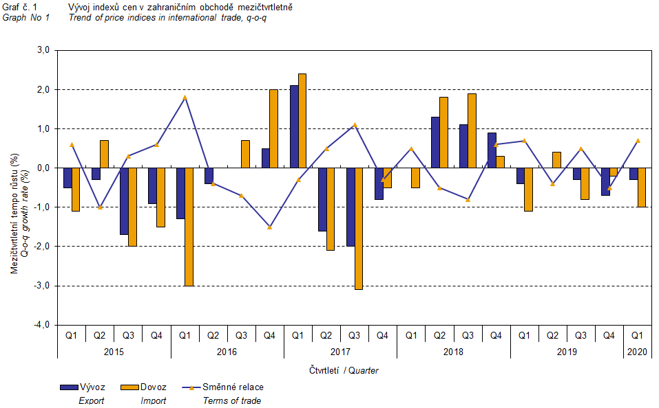

The international trade price development was also significantly affected by the CZK exchange rate to the major foreign currencies. The q-o-q exchange rate index includes two most important currencies from the Czech Republic’s international trade point of view, i.e. EUR and USD. Q-o-q indices of the CZK exchange rate to these currencies were weighted by the weight, which pertains to those foreign currencies in the export price index and import price index, respectively.

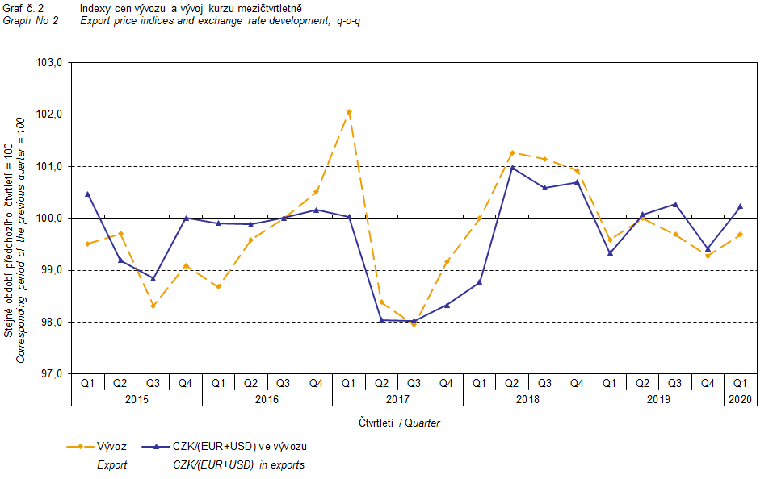

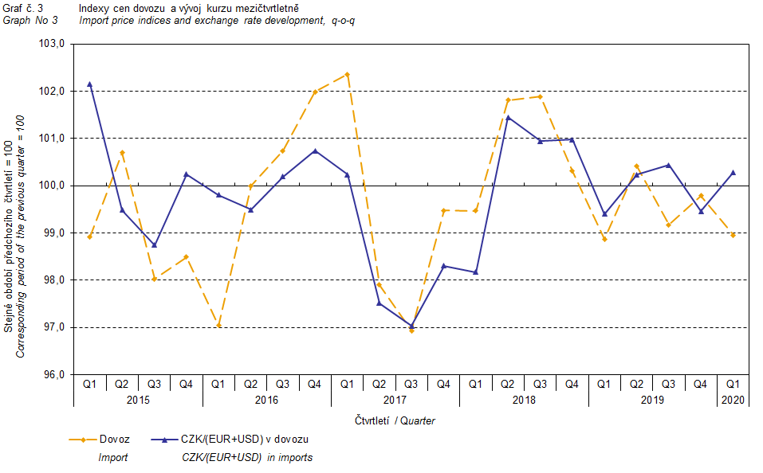

It is apparent from the Graph No 2 and Graph No 3 above that in both exports and imports, international trade prices have a strong relation to exchange rate impacts. Contracts with foreign entities are usually concluded for a longer period and the longer the contract period is, the stronger the relation to exchange rates is.

# Year-on-year comparison

In the Q1 2020, export prices decreased by 1.4%, y-o-y (in the Q4 2019 it was also by 1.4%, y-o-y). Prices of the following decreased the most: 'crude materials, inedible, except fuels' (−13.3%), 'mineral fuels, lubricants and related materials' (−11.7%), and 'manufactured goods classified chiefly by material' (−3.5%). Prices of 'miscellaneous manufactured articles' and ‘food and live animals’ increased by 1.7% and 1.2%, respectively.

Import prices in the Q1 2020 decreased by 1.7%, y-o-y (in the Q4 2019 they dropped by 1.8%, y-o-y). Prices of 'mineral fuels, lubricants and related materials' decreased by 12.5% followed by prices of 'chemicals and related products’ (−4.8%) and prices of 'crude materials, inedible, except fuels' (−4.4%). Increasing were only prices of ‘food and live animals’ (+6.9%) and prices of 'machinery and transport equipment’ (+0.7%).

In the Q1 2020, the terms of trade reached the value of 100.3%, year-on-year (in the Q4 2019 they were at the value of 100.4%, y-o-y) and remained in positive values, see Graph No 4 below. The highest positive values of the terms of trade were recorded by ‘beverages and tobacco’ (107.3%), 'chemicals and related products’ (102.6%), and 'miscellaneous manufactured articles' (101.8%). Negative values of the terms of trade were recorded for 'crude materials, inedible, except fuels' (90.7%), ‘food and live animals’ (94.7%), and 'machinery and transport equipment’ (99.2%).

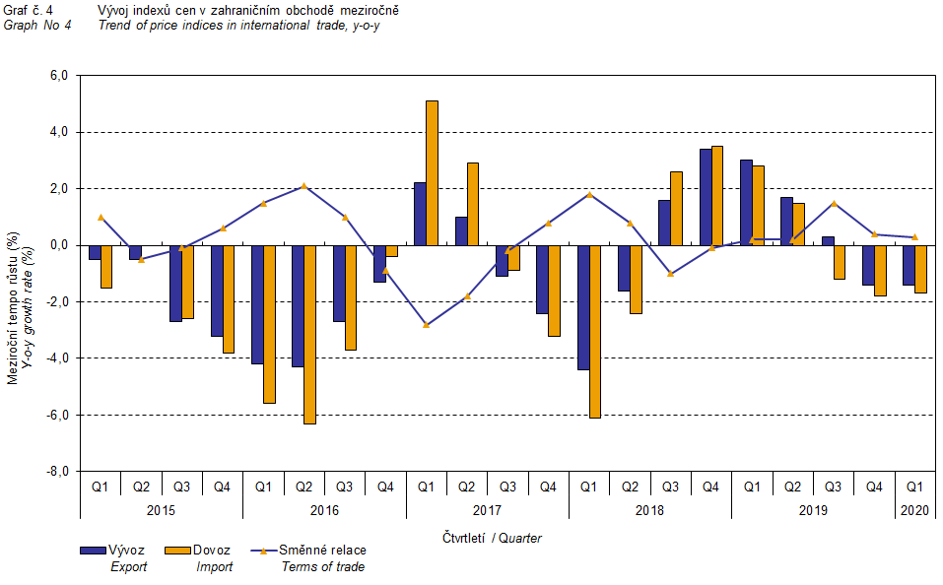

# International trade price indices, year-on-year, adjusted for exchange rate influence

The Czech Statistical Office also carries out calculations of year-on-year international trade price indices adjusted for effects of exchange rate. Prices in foreign currencies reported in the current month are **converted** to Czech crowns by the **exchange rate** of the same month **of the previous year**. Then they are used for the weighted mean calculation along with prices reported in CZK. The year-on-year adjusted price index for a month is then calculated the way that this exchange rate adjusted base price index of a month is related to the non-adjusted base price index of the corresponding month of the previous year. Similarly, adjusted quarter-on-quarter price indices are calculated since 2017. **Differences between adjusted and non-adjusted price indices may be considerable**; they are obvious in the Graph No 6 and Graph No 7, for example, in the Q1 2018.

The method employed does not enable to make a 100% exchange rate adjustment because not all trade transactions made in foreign currencies are reported in foreign currencies; the share does not exceed 30%. From the aforementioned it follows that, **at the full exchange rate adjustment, differences** between the price indices published and the exchange rate adjusted price indices **would** probably further **increase**.

The aforementioned exchange rate adjusted indices can be used to form the exchange rate adjusted breakdown of price indices increments. Table 1 gives the **published and exchange rate adjusted breakdowns of increments** of export and import price indices, expanded by the most important two-digit code groups of the SITC 7. The breakdown illustrates well how many percentage points each of the groups “exchange rate contributed” to the index.

In general, it is true that the exchange rate effect decreases the value of price indices in international trade if CZK is strengthening to foreign currencies in total. Conversely, the exchange rate effect pushes the price indices up if CZK is weakening to foreign currencies in total.

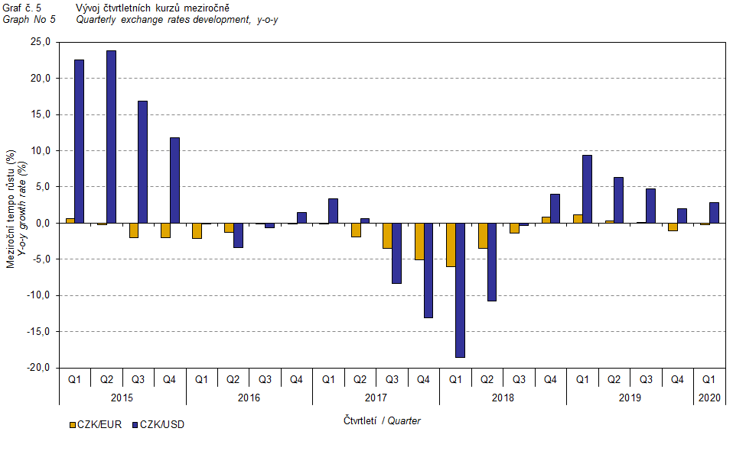

From the Graph No 6 and Graph No 7 below, it is apparent how significant the exchange rate influence on the value of the export and import price indices was.

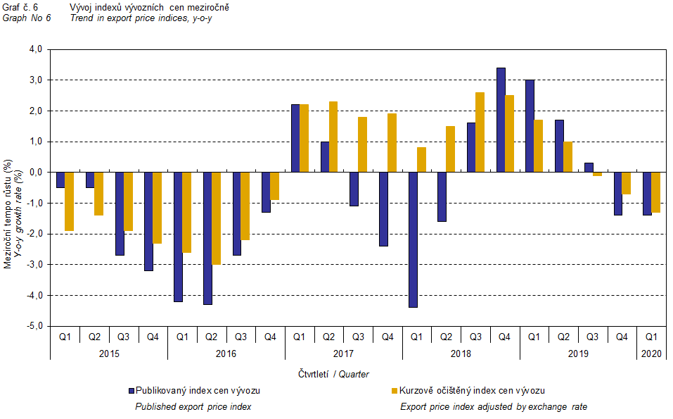

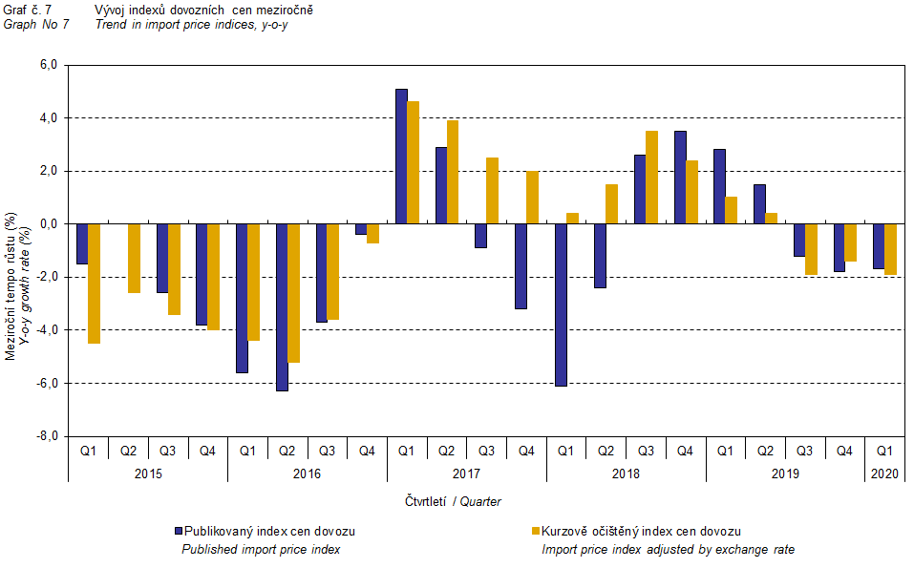

Graph No 8 shows the exchange rate influence on the value of the year-on-year terms of trade.

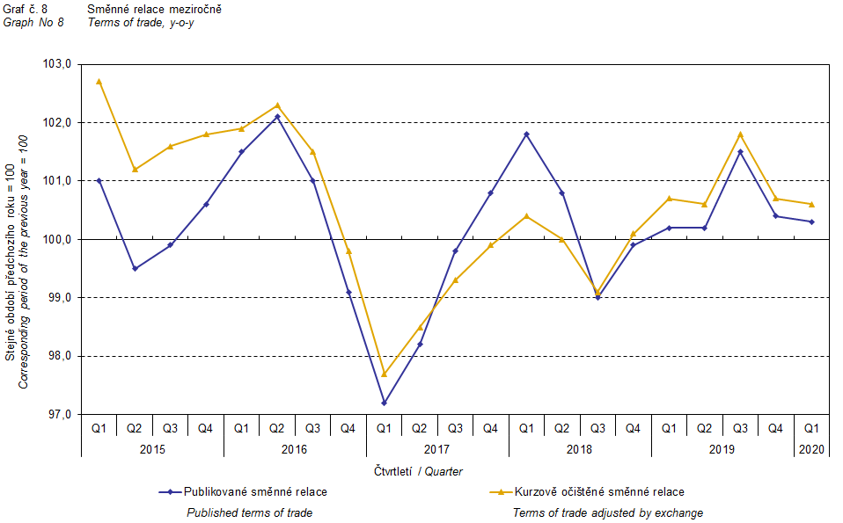

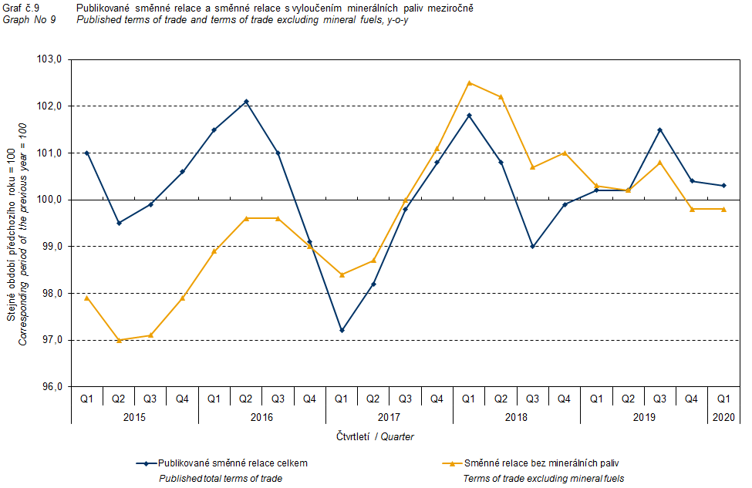

Graph No 9 shows the development of the value of the terms of trade when the group of 'mineral fuels, lubricants and related materials' is excluded. It can be observed in the graph that the effects of 'mineral fuels, lubricants and related materials' were increasing the overall value of the y-o-y terms of trade until the Q4 2016. In the Q1 2017, the situation changed and 'mineral fuels, lubricants and related materials' started to have a downward effect on the value of the terms of trade, which continued until the Q1 2019. In the Q2 2019, as an exception, 'mineral fuels, lubricants and related materials' had no effect on the terms of trade value. Since the Q3 2019, 'mineral fuels, lubricants and related materials' started to raise the terms of trade value again. Naturally, it is related to the world market price development, especially in crude oil. Import prices, which, compared to export prices, include a higher proportion of crude materials, respond in a more sensitive way to price turbulences. Therefore, when prices of crude materials go up, the terms of trade, as a rule, go down, and, conversely, when prices of crude materials fall, the terms of trade grow.

# Closing summary

In the Q1 2020, the exchange rate effect deepened the decrease of the export price index and slackened the decrease of import prices, year-on-year. Export prices were decreasing less than import prices, y-o-y, and therefore the terms of trade reached positive values. After elimination of the exchange rate effect, the terms of trade were also positive. Values free of the exchange rate effect correspond to the exchange rate adjusted indices, see Graphs No 6, 7, and 8.



The closing table gives published **non-adjusted** international trade price indices.



Note: In tables and graphs, the publication uses the Czech decimal comma, instead of the English decimal point, as decimal separator for internal reasons.

**Elaborated by:** Vladimír Klimeš, Prices Statistics Department

phone number: (+420) 274 054 102, e-mail: [vladimir.klimes@czso.cz](mailto:vladimir.klimes@czso.cz)