10 November 2023

Development of international trade in goods price indices in the Q3 2023

In the Q3 2023, compared to the Q2 2023, export prices increased by 0.7%. In the year-on-year (y-o-y) comparison, export prices decreased by 4.4% in the Q3 2023. Import prices increased by 1.3% in the Q3 2023 compared to the Q2 2023. In the y-o-y comparison, import prices decreased by 11.2% in the Q3 2023. The terms of trade reached the value of 99.4% in the Q3 2023 compared to the Q2 2023. In the year-on-year comparison, the terms of trade reached the value of 107.7% in the Q3 2023.

**Export prices**

**Quarter-on-quarter** (q-o-q; in the Q3 2023 compared to the Q2 2023), they increased by 0.7%. The following prices increased the most: prices of ‘machinery and transport equipment’ by 2.1%, ‘miscellaneous manufactured articles’ by 1.9%, and prices of ‘mineral fuels, lubricants and related materials’ by 1.2%. Mainly prices of the following decreased: prices of ‘crude materials, inedible, except fuels’ by 7.9% (especially prices of cork and wood), ‘chemicals and related products’ (especially organic chemicals) by 2.2%, and prices of ‘manufactured goods classified chiefly by material’ by 1.0%.

**Year-on-year**, in the Q3 2023, they decreased by 4.4% (in the Q2 2023 it was by 1.8%). The biggest price decrease was in ‘crude materials, inedible, except fuels’ by 23.0% (especially prices of cork and wood), ‘mineral fuels, lubricants and related materials’ by 18.8% (prices of electric current, petroleum products, and coal), and ‘chemicals and related products’ (mainly organic chemicals and plastics) by 13.4%. The highest price increase was in ‘beverages and tobacco’ by 14.7% and in ‘machinery and transport equipment’ by 1.5%.

**Import prices**

**Quarter-on-quarter** (in the Q3 2023 compared to the Q2 2023), they increased by 1.3%. Prices of ‘mineral fuels, lubricants and related materials’ increased by 6.2% (primarily prices of petroleum and petroleum products), ‘food and live animals’ by 2.0%, and both ‘miscellaneous manufactured articles’ and ‘machinery and transport equipment’ by 1.7%. Prices of ‘crude materials, inedible, except fuels’ decreased by 4.4% (primarily prices of metalliferous ores and metal scrap), prices of ‘chemicals and related products’ by 0.9%, and prices of ‘manufactured goods classified chiefly by material’ by 0.5%.

**Year-on-year**, in the Q3 2023, they decreased by 11.2% (in the Q2 2023 they dropped by 7.6%). The biggest price decrease was in ‘mineral fuels, lubricants and related materials’ by 44.7% (mainly prices of gas and electric current), ‘crude materials, inedible, except fuels’ by 17.2% (mainly prices of metalliferous ores and metal scrap), and ‘chemicals and related products’ (especially plastics) by 12.0%. Prices of ‘beverages and tobacco’ increased by 20.9% (tobacco prices the most); prices of ‘miscellaneous manufactured articles’ grew by 3.8% and prices of ‘food and live animals’ by 3.1%.

**The terms of trade**

**Quarter-on-quarter** (in the Q3 2023 compared to the Q2 2023), they reached the value of 99.4%. The lowest negative value of the terms of trade was reached by ‘mineral fuels, lubricants and related materials’ (95.2%). The highest positive value was recorded by ‘machinery and transport equipment’ (100.4%).

**Year-on-year**, in the Q3 2023, they increased to the value of 107.7% (in the Q2 2023 the value was 106.3%) and for the third quarter they remained in the positive values – see the Chart No 2. The highest positive value of the terms of trade was recorded by ‘mineral fuels, lubricants and related materials’ (146.8%) and the lowest negative value by ‘food and live animals’ (91.8%).

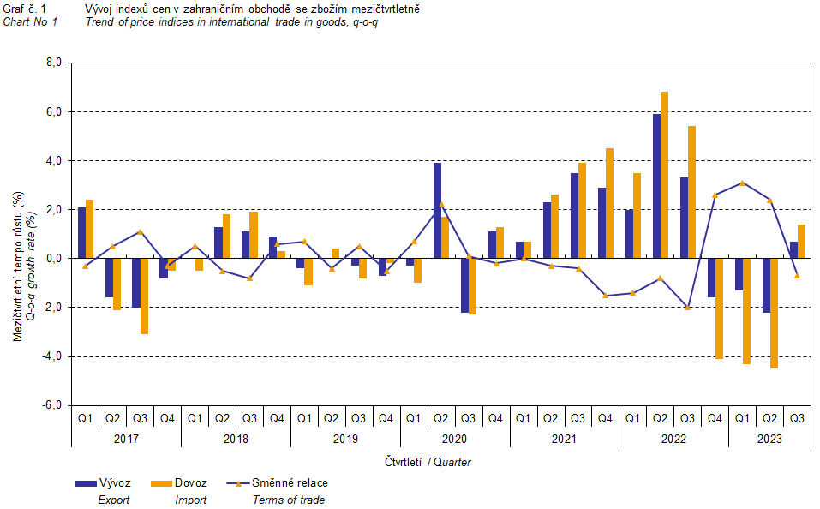

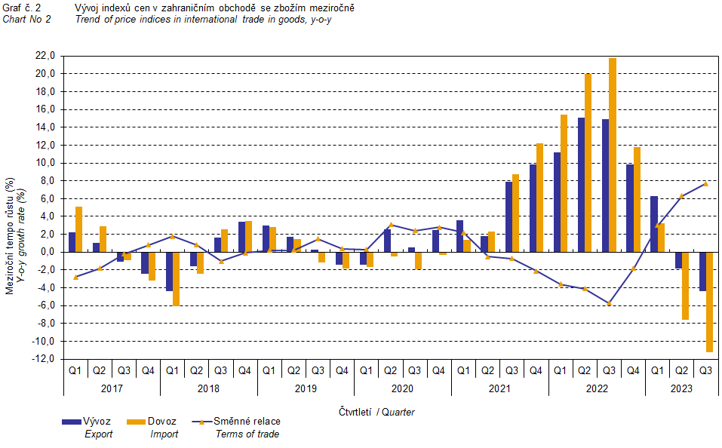

The international trade in goods (change of ownership) price development was also significantly influenced by the CZK exchange rate to the major foreign currencies. All monitored foreign currencies have been included in the **quarter-on-quarter** **exchange rate** **index**. Q-o-q indices of the CZK exchange rate to these currencies were weighted by the respective weight, which pertains to those foreign currencies in the export price index and in the import price index (before the Q3 2023, only two most important currencies, i.e. EUR and USD, have been included; as of the Q3 2023, the calculation was refined by inclusion of all currencies and it was calculated backwards to the year 2021).

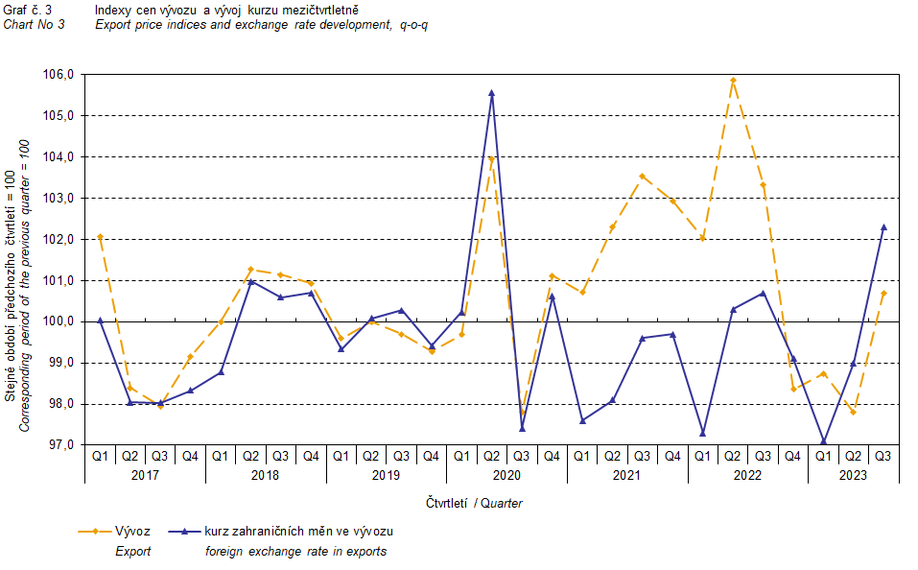

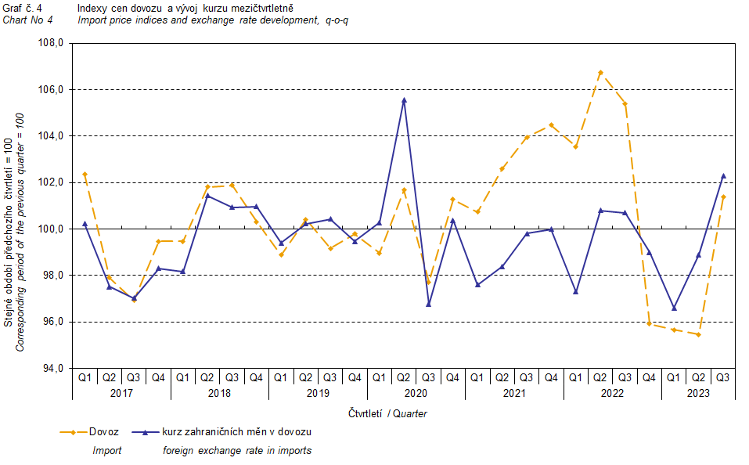

It is apparent from the Chart No 3 and the Chart No 4 above that in both exports and imports, international trade in goods prices have a relation to exchange rate effects. Contracts with foreign entities are usually concluded for a longer period of time and the longer the contract period is, the stronger the relation to exchange rates is.

# International trade in goods price indices, year-on-year, adjusted for exchange rate influence

The Czech Statistical Office (CZSO) also calculates year-on-year international trade in goods price indices adjusted for exchange rate effects. It is carried out as follows: prices in foreign currencies reported in the current month are **converted** to Czech crowns **by the exchange rate** of the same month **of the previous year**. Then they are used for the weighted mean calculation together with prices reported in CZK. This exchange rate adjusted base price index of a month is related to the non-adjusted base price index of the corresponding month of the previous year and thus the year-on-year adjusted price index for a month is calculated.

Since 2017, adjusted quarter-on-quarter price indices have been calculated similarly, too. **Differences between adjusted and non-adjusted price indices may be considerable**. They are obvious in the Chart No 6 and the Chart No 7, for example, in the Q1 2018 and in the Q2 2021.The method employed does not enable to make a 100% exchange rate adjustment because not all trade transactions made in foreign currencies are also reported in foreign currencies; the proportion does not exceed 30%. From the aforementioned it follows that **at the full exchange rate adjustment, differences** between the price indices published and the exchange rate adjusted price indices **would** probably further **increase**.

The exchange rate adjusted indices described above can also be used to make the exchange rate adjusted breakdown of increments of price indices. The Table 1 gives the **published and exchange rate adjusted breakdown of increments** of export and import price indices, supplemented by the most important two-digit code groups of the SITC 7. The breakdown illustrates well how many percentage points each of the groups “exchange rate contributed” to the index.

# It is generally true that the exchange rate effect decreases the value of price indices in international trade in goods if CZK is strengthening to foreign currencies in total. Conversely, the exchange rate effect pushes the price indices up if CZK is weakening to foreign currencies in total.

The Chart No 5 below illustrates the CZK exchange rate to the two most important foreign currencies, i.e. to EUR and USD.

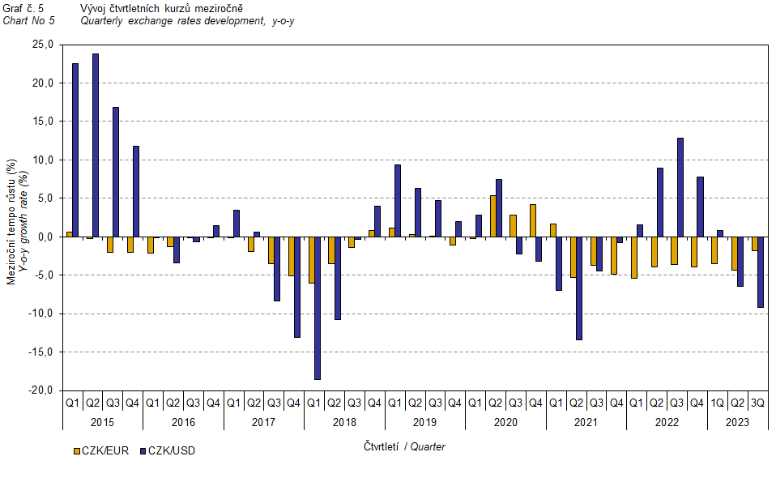

It is apparent from the Chart No 6 and the Chart No 7 below how significant the exchange rate influence of all monitored foreign currencies on the value of the export and import price indices was.

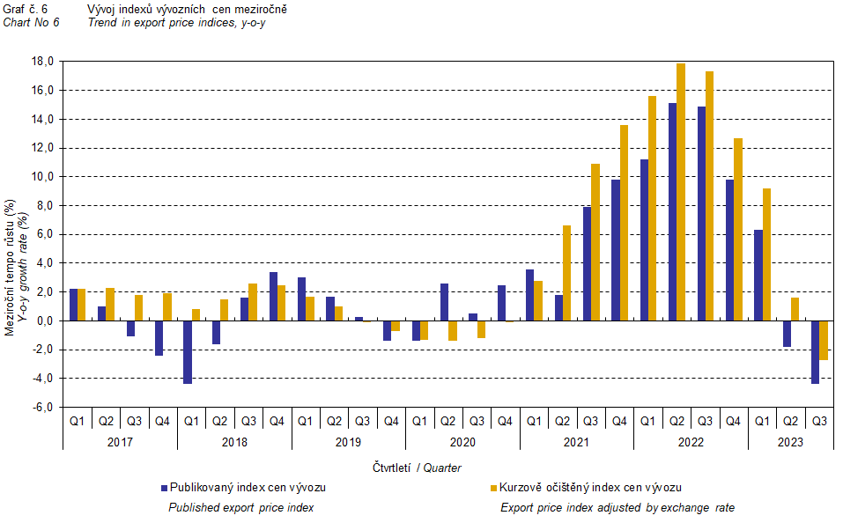

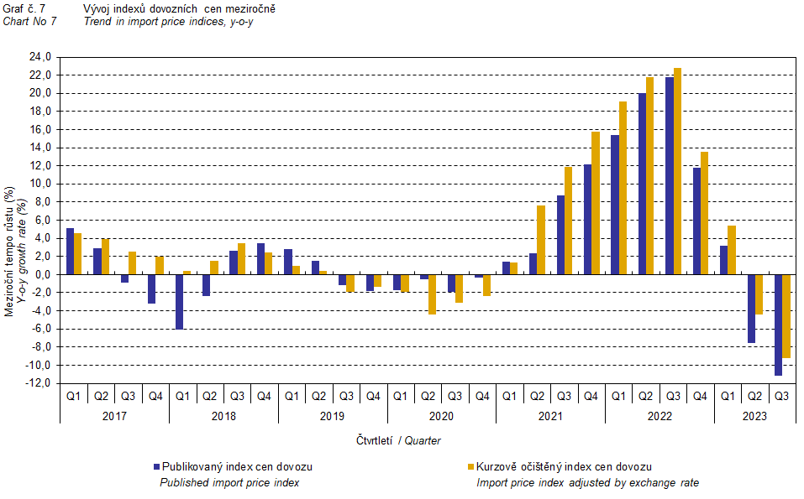

The Chart No 8 shows the exchange rate influence on the value of the year-on-year terms of trade.

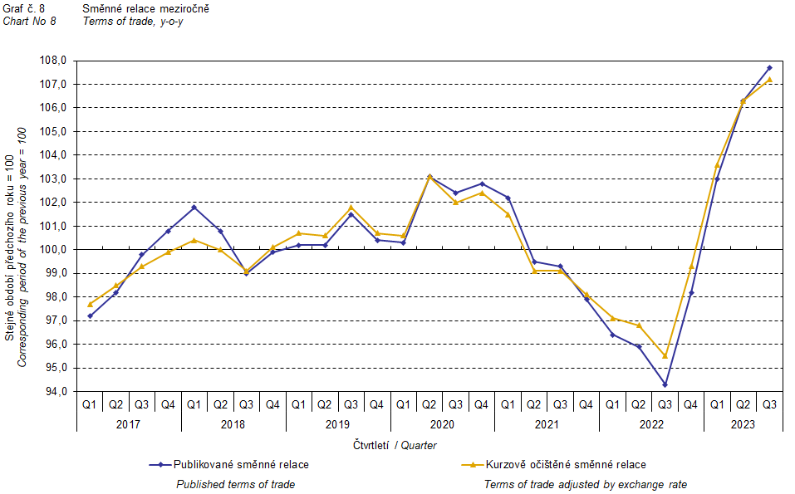

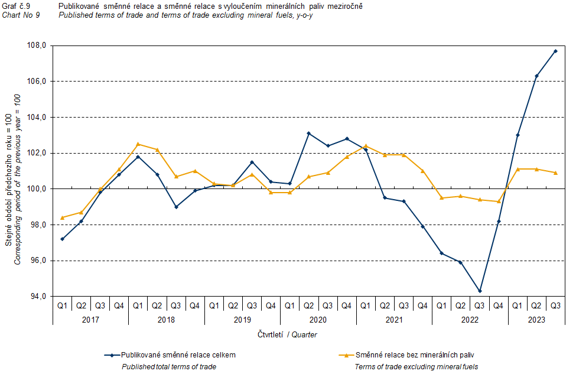

The Chart No 9 shows the development of the value of the terms of trade when the group of ‘mineral fuels, lubricants and related materials’ is excluded. In this chart, the effect of ‘mineral fuels, lubricants and related materials’ can be observed; it has an influence on the total value of the y-o-y terms of trade. Since the Q1 2021, ‘mineral fuels, lubricants and related materials’ were decreasing the value of the terms of trade; however, in the Q1 2023, there was a turnabout and ‘mineral fuels, lubricants and related materials’ started to increase the value of the terms of trade. Naturally, it is related to the world market price development, especially as for petroleum prices. Import prices, which, compared to export prices, have a higher proportion of crude materials, respond in a more sensitive way to price turbulences. Therefore, the terms of trade are usually increasing when prices of crude materials are decreasing, and, vice versa, when prices of crude materials are increasing, the terms of trade are decreasing.

# Final summary

In the Q3 2023, the exchange rate effect decreased both the export price index and the import prices index, **year-on-year**. Import prices decreased more than export prices and therefore the terms of trade reached positive values, **year-on-year**. After elimination of the exchange rate effect, the terms of trade were lower than the published terms of trade. Values free of the exchange rate effect correspond to the exchange rate adjusted indices – see the Charts Nos. 6, 7, and 8.



The closing table gives published **non-adjusted** international trade in goods price indices. 

*Note: For internal reasons, the Czech decimal comma is used instead of the English decimal point as a decimal separator in tables and charts of this analysis.*

**Elaborated by:** Vladimír Klimeš, Prices Statistics Department

phone number: (+420) 274 054 102, e-mail: vladimir.klimes@czso.cz