7 November 2022

Industrial production in the third quarter increased by 5.5%, year-on-year

Supplementary information to the News Release on Industry – September 2022
Industry in the third quarter
Industrial production was in real terms by 2.1% higher in the Q3 2022, quarter-on-quarter. In the year-on-year comparison, it increased by 5.5%. The third quarter of 2022 had the same number of working days as the corresponding quarter of the previous year.
The production growth rate in the Q3 was considerably influenced by outages of production in the car industry in the previous year. This economic activity (industry) contributed with 5.9 percentage points (p. p.) to the total growth of industry. Manufacture of machinery and equipment as well as manufacture of electrical equipment contributed with +0.5 p. p. each; their production also increased the same, by 6%, year-on-year. Mining of black and brown coal increased by over a fifth, year-on-year, as a result of increased demand related to growing prices of electricity and natural gas.
In the year-on-year comparison, production decreased the most in the following: manufacture of fabricated metal products (a contribution -0.5 p. p., a decrease by 4.5%), manufacture of basic metals (a contribution -0.4 p. p., a decrease by 12.4%), and manufacture of other transport equipment (a contribution -0.3 p. p., a decrease by 12.6%).
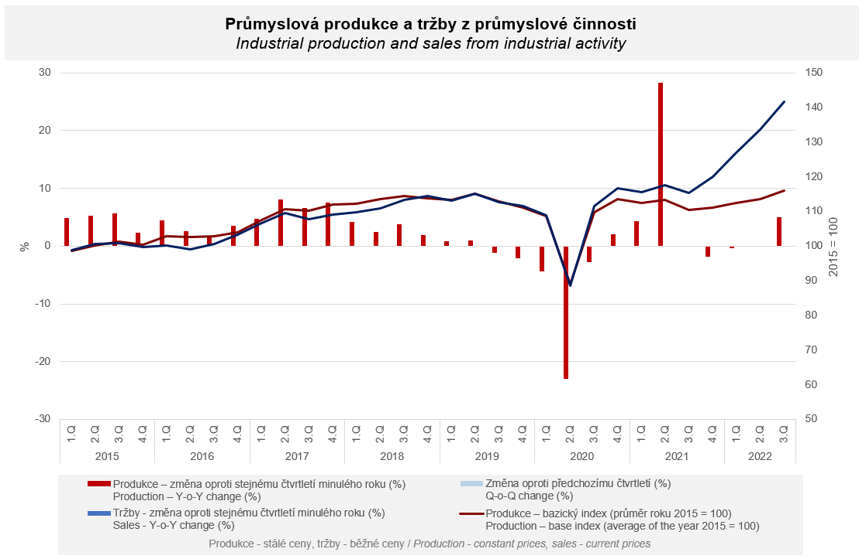
Sales from industrial activity at current prices increased by 23.3% in the Q3 2022. Direct export sales of industrial enterprises increased at current prices by 20.0%. Domestic sales, which also include indirect export via non-industrial enterprises, increased at current prices by 27.7%.
The following contributed the most to the increase: manufacture of motor vehicles, trailers and semi-trailers (a contribution +7.8 p. p, an increase by 40.1%), electricity, gas, steam and air conditioning supply (a contribution +5.1 p. p, double increase), and manufacture of food products (a contribution +1.5 p. p, an increase by 21.3%). A decrease was only recorded in four economic activities as follows: manufacture of wood and of products of wood and cork, except furniture; manufacture of articles of straw and plaiting materials, manufacture of furniture, other manufacturing, and mining support service activities. However, in all those economic activities it was a slight, approximately 2% y-o-y decrease in the value of sales.
Similarly as in the previous quarters, sales from industrial activity were increasing with a double-digit growth rate, year-on-year, in most of economic activities (industries). It was mainly as a consequence of dynamic growth of prices of both raw materials and finished goods. This influence was more considerable in domestic sales.

The value of new orders at current prices in surveyed industrial CZ-NACE activities in the Q3 2022 increased by 13.9%, year-on-year. Non-domestic new orders increased by 9.6%. Domestic new orders increased by 23.5%.
The following contributed the most to the increase of the value of new orders: manufacture of motor vehicles, trailers and semi-trailers (a contribution +7.3 percentage points (p. p.), an increase by 21.4%), manufacture of fabricated metal products (a contribution +1.6 p. p., an increase by 11.8%), and manufacture of electrical equipment (a contribution +1.4 p. p., an increase by 13.7%). A decrease was only recorded by manufacture of other transport equipment (a contribution -0.4 p. p., a decrease by 14.8%).

The average registered number of employees in industry in the Q3 2022 was by 0.1% lower compared to the corresponding period of the previous year. Their average gross monthly nominal wage increased by 7.9%.

Notes:

Contact person: Veronika Doležalová, Head of Industrial Statistics Unit, phone number (+420) 734 352 291, e-mail: veronika.dolezalova@czso.cz

Related outputs: time series in the Public database, the Industry chapter

