8 August 2022

Industrial production in the first half-year was on the same level as a year ago

Supplementary information to the News Release on Industry – June 2022
Industry in the first half-year
Industrial production was in real terms by 2.4% higher in the first half-year of 2022 compared to the second half-year of 2021 and reached the same level as in the first half-year of 2021. The first half-year of 2022 had one working day more than the second half-year of the previous year.
In the first quarter of 2022, there were problems with supplies of components for motor vehicles on one side, yet there was also growth of majority of economic activities of industry on the other. In the second quarter, the situation in the automotive segment improved, however, in many other industries the year-on-year growth stopped. Mainly in some economic activities (industries) with high energy intensity, the complicated situation and growing prices started to be reflected.

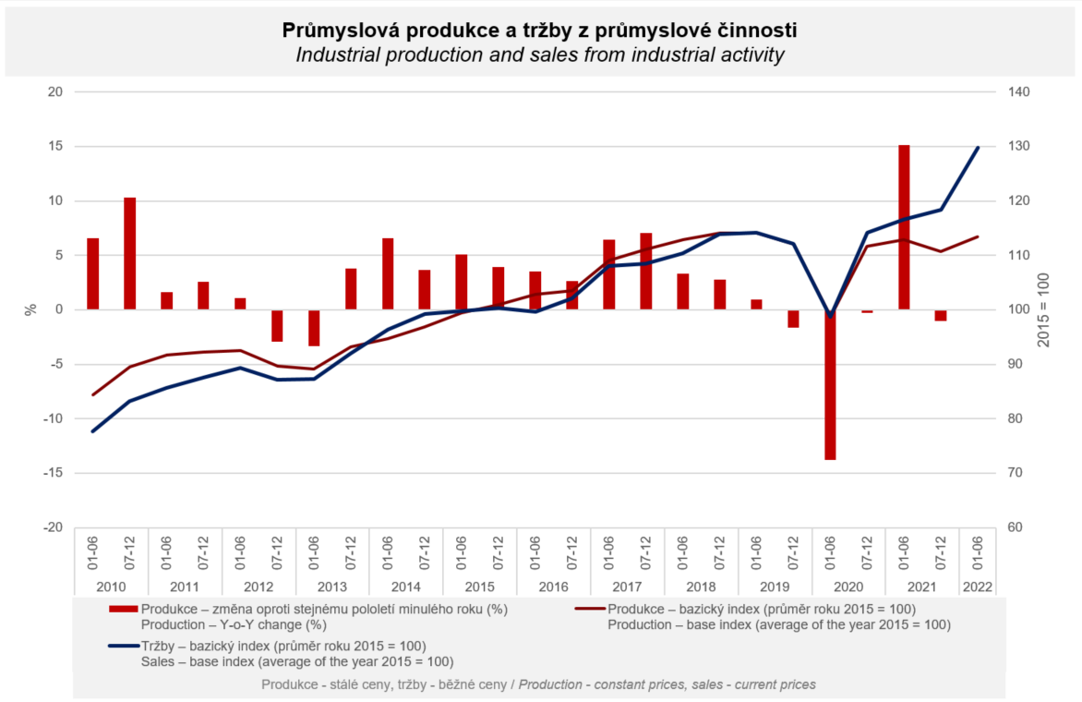

The result for the first half-year of 2022 in total was positively influenced the most by manufacture of electrical equipment (a year-on-year increase by 3.6%, a contribution +0.3 p. p.), manufacture of beverages (an increase by 12%, a contribution +0.2 p. p.), and manufacture of basic pharmaceutical products and pharmaceutical preparations (an increase by 11.1%, a contribution +0.2 p. p.). On the other hand, the highest negative contributions were recorded by manufacture of machinery and equipment (a year-on-year decrease by 4.3%, a contribution -0.8 p. p.), manufacture of wood and of products of wood (a decrease by 10.8%, a contribution -0.2 p. p.), and manufacture of rubber and plastic products (a decrease by 2.9%, a contribution -0.2 p. p.).

Sales from industrial activity at current prices increased by 11.3% in the first half-year of 2022. Direct export sales of industrial enterprises increased at current prices by 6.7%. Domestic sales, which also include indirect export via non-industrial enterprises, increased at current prices by 17.8%.
A year-on-year decrease of sales was only recorded by manufacture of motor vehicles, trailers and semi-trailers, namely by 5% and sales in manufacture of computer, electronic and optical products were the same as a year ago. A considerable difference between sales at current prices and production, which is adjusted for price effects, was mainly obvious in mining and quarrying (a year-on-year increase of sales in the first half-year of 2022 by 41%, production growth by 5.5%), manufacture of basic metals (an increase of sales by 36%, a production decrease by 2.3%), and manufacture of chemicals and chemical products (an increase of sales by 35%, production growth by 3.5%). However, production was increasing with a double-digit growth rate in almost all economic activities of industry.

The value of new orders at current prices in surveyed industrial CZ-NACE activities in the first half-year of 2022 increased by 7.4%, year-on-year. Non-domestic new orders increased by 6.2%. Domestic new orders increased by 10.1%. The growth rate of the value of orders was lower than the growth rate of the value of sales. Mainly in the end of the half-year, in some economic activities (industries) a large amount of work in progress of previously contracted orders started to be reflected.
The following contributed the most to the increase of the value of new orders: manufacture of fabricated metal products (a year-on-year increase by 18.7%, a contribution +2.2 percentage points (p. p.)), manufacture of chemicals and chemical products (an increase by 34.0%, a contribution +1.8 p. p.), and manufacture of electrical equipment (an increase by 13.1%, a contribution +1.3 p. p.). A decrease was only recorded by manufacture of motor vehicles, trailers and semi-trailers (a decrease by 3.2%, a contribution -1.3 p. p.) and manufacture of computer, electronic and optical products (a decrease by 0.4%, a contribution -0.03 p. p.).

The average registered number of employees in industry in the first half-year of 2022 was by 0.1% higher compared to the corresponding period of the previous year. Their average gross monthly nominal wage increased by 7.5%.

Notes:

Contact person: Veronika Doležalová, Head of Industrial Statistics Unit, phone number (+420) 734 352 291, e-mail: veronika.dolezalova@czso.cz

Related outputs: time series in the Public database, the Industry chapter

