7 August 2023

Industrial production increased by 1.2%, year-on-year, in the first half-year

Supplementary information to the News Release on Industry – June 2023
Industry in the first half-year
Industrial production was in real terms by 0.5% lower in the first half-year of 2023 compared to the second quarter of 2022. In the year-on-year comparison, it increased by 1.2%. The first half-year of 2023 had by 1 working day less compared to the first half-year of 2022.
The following contributed the most to a slight increase: manufacture of motor vehicles, trailers and semi-trailers (a contribution of +4.5 percentage points (p. p.), growth by 24.7%), in which besides the influence of the comparison basis also recovery of production both in the segment of car production and in production of components was reflected. Manufacture of other transport equipment recorded an increase by almost 20% (a contribution of +0.4 p. p.), namely thanks to a completion of important long-term orders in the end of the half-year. The third highest positive contribution came from manufacture of electrical equipment (contribution +0.4 p. p., growth by 5.2%). The first half-year of 2023 was successful for pharmaceutical industry, in which production increased by 10.5%.
However, during the whole first half-year, production of most of economic activities of industry was decreasing, year-on-year. The highest negative contributions were recorded by the following ones: electricity, gas, steam and air conditioning supply (a contribution of -1.1 p. p., a drop by 11.4%), manufacture of other non-metallic mineral products (a contribution of -0.8 p. p., a drop by 17.1%), and manufacture of chemicals and chemical products (a contribution of -0.5 p. p., a drop by 14.5%). Production in manufacture of basic metals decreased by 17.9% and in mining and quarrying by 13.8%.

Results of individual quarters were balanced. In the first quarter, industrial production increased by 1.2%. In individual months, the development fluctuated and the results depended on the current situation in the automobile industry, in which a low comparison basis from the last year was reflected on one side and partial problems with supplies of components emerged again on the other side. In the Q2, the production increased by 1.1%, y-o-y. The influence of the low comparison basis in car production receded, whereas last year’s increased brown coal mining and production of coal power plants was reflected in considerable decreases in mining and quarrying and production of electricity and gas. In the Q2, production increased by 0.9% compared to the Q1.

Sales from industrial activity at current prices increased by 8.3%, y-o-y, in the first half-year of 2023. Direct export sales of industrial enterprises increased at current prices by 6.8%. Domestic sales, which also include indirect export via non-industrial enterprises, increased at current prices by 10.2%.
The following contributed the most to the growth: manufacture of motor vehicles, trailers and semi-trailers (a contribution of +5.9 p. p., an increase by 27.1%), electricity, gas, steam and air conditioning supply (a contribution of +2.6 p. p., an increase by 38.1%), and manufacture of food products (a contribution of +0.9 p. p., an increase by 13.4%). Sales in mining of both black and brown coal increased by over a quarter.
On the other hand, sales from industrial activity decreased the most in manufacture of basic metals (a contribution of -1.2 p. p., a decrease by 22.8%), manufacture of chemicals and chemical products (a contribution of -0.9 p. p., a decrease by 19.6%), and in wood processing industry (a contribution of -0.5 p. p., a decrease by 20.1%).

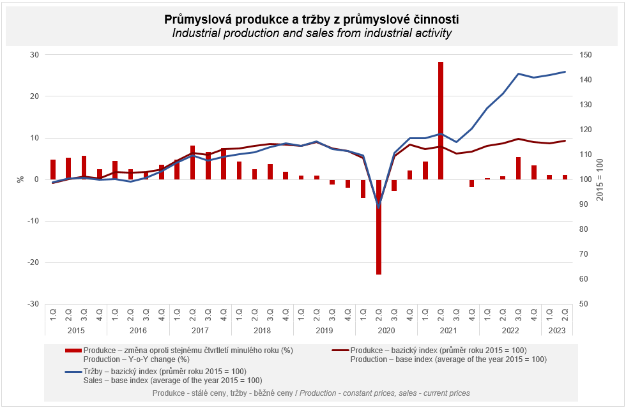

The value of new orders at current prices in surveyed industrial CZ-NACE activities in the first half-year of 2023 decreased by 0.3%, year-on-year. Non-domestic new orders decreased by 3.4%. Domestic new orders increased by 6.3%.
The following contributed the most to the decrease of the value of new orders: manufacture of basic metals (a contribution of -1.7 p. p., a decrease by 22.1%), manufacture of chemicals and chemical products (a contribution of -1.1 p. p., a decrease by 17.3%), and manufacture of fabricated metal products (a contribution of -0.6 p. p., a decrease by 4.6%).
The highest positive contributions were recorded by manufacture of motor vehicles, trailers and semi-trailers (a contribution of +2.3 p. p., an increase by 6.4%), manufacture of machinery and equipment (a contribution of +0.3 p. p., an increase by 2.9%), and manufacture of electrical equipment (a contribution of +0.3 p. p., an increase by 2.8%).

The average registered number of employees in industry in the first half-year of 2023 was by 1.4% lower compared to the corresponding period of the previous year. Their average gross monthly nominal wage increased by 10.2%.

Notes:

Contact person: Iveta Danišová, Industrial Statistics Unit, phone number (+420) 735 130 317, e-mail: iveta.danisova@czso.cz

Related outputs: time series in the Public database, the Industry chapter

