6 November 2023

Industrial production decreased by 0.3% in the Q1–Q3

Supplementary information to the News Release on Industry – September 2023
Industry in the Q1–Q3
Industrial production was by 0.3% lower in the Q1–Q3 of 2023, year-on-year. In the first to the third quarter of 2023, there were by 2 working days less compared to the corresponding period of 2022.
The following economic activities (industries) recorded the highest negative contributions: electricity, gas, steam and air conditioning supply (a contribution of -1.2 p. p., a decrease by 12.3%), manufacture of other non-metallic mineral products (a contribution of -0.8 p. p., a decrease by 17.8%), and manufacture of basic metals (a contribution of -0.4 p. p., a decrease by 16.2%).
However, only a minority of industries recorded an increase. The highest positive contributions were recorded by the following ones: manufacture of motor vehicles, trailers and semi-trailers (a contribution of +3.4 p. p., an increase by 18.0%), manufacture of other transport equipment (contribution +0.3 p. p., an increase by 16.1%), namely by completion of important long-term orders in the end of the half-year. The third highest positive contribution came from manufacture of electrical equipment (contribution +0.3 p. p., an increase by 3.7%). The year 2023 is successful for pharmaceutical industry, in which production increased by 11.7%.

Results of the first two quarters were balanced and industry ended up in a slight growth, whereas in the third quarter performance of the industry started to slow down. In the Q1, the industrial production increased by 1.2%, in the Q2 by 1.1%. In the Q3, the production decreased by 3.3%, y-o-y; compared to the previous quarter it decreased by 2.1%. An absolute majority of economic activities of industry recorded a decrease in production; in many industries, a lack of demand was strengthening. Neither the traditional driving force of Czech industry, manufacture of motor vehicles, trailers and semi-trailers, nor manufacture of other transport equipment (in which important long-term orders from previous periods were being completed and concurrently new ones were made) were able to keep industrial production growing as a whole.

Sales from industrial activity at current prices increased by 4.3%, y-o-y, in the first to the third quarter of 2023. Direct export sales of industrial enterprises increased at current prices by 3.0%. Domestic sales, which also include indirect export via non-industrial enterprises, increased at current prices by 5.9%.
The following contributed the most to the growth: manufacture of motor vehicles, trailers and semi-trailers (a contribution of +4.5 p. p., an increase by 20.4%), electricity, gas, steam and air conditioning supply (a contribution of +1.4 p. p., an increase by 19.9%), and manufacture of food products (a contribution of +0.6 p. p., an increase by 8.7%). Sales in mining of black and brown coal increased by almost a quarter.
On the other hand, sales from industrial activity decreased the most in manufacture of basic metals (a contribution of -1.1 p. p., a decrease by 24.0%), manufacture of chemicals and chemical products (a contribution of -0.9 p. p., a decrease by 19.8%), and in manufacture of wood and of products of wood and cork, except furniture; manufacture of articles of straw and plaiting materials (a contribution of -0.5 p. p., a decrease by 21.4%).

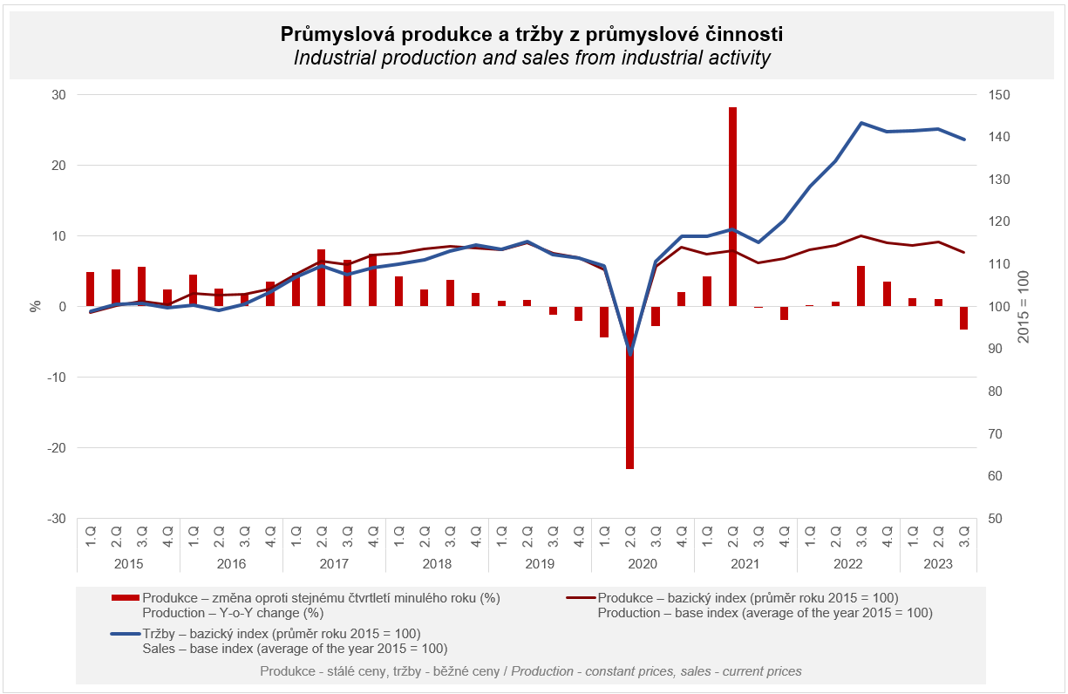

The value of new orders at current prices in surveyed industrial CZ-NACE activities in the Q1–Q3 of 2023 decreased by 1.9%, year-on-year. Non-domestic new orders decreased by 3.8%. Domestic new orders increased by 1.9%.
The following contributed the most to the decrease of the value of new orders: manufacture of basic metals (a contribution of -1.5 p. p., a decrease by 21.3%), manufacture of chemicals and chemical products (a contribution of -1.2 p. p., a decrease by 18.4%), and manufacture of fabricated metal products (a contribution of -0.7 p. p., a decrease by 5.1%).
The highest positive contributions were recorded by manufacture of motor vehicles, trailers and semi-trailers (a contribution of +1.9 p. p., an increase by 5.4%), manufacture of electrical equipment (a contribution of +0.3 p. p., an increase by 2.4%), and manufacture of basic pharmaceutical products and pharmaceutical preparations (a contribution of +0.2 p. p., an increase by 14.9%).

The average registered number of employees in industry in the Q1–Q3 of 2023 was by 1.6% lower compared to the corresponding period of the previous year. Their average gross monthly nominal wage increased by 9.4%.

Contact person: Veronika Doležalová, Head of the Industrial Statistics Unit, phone number (+420) 734 352 291, e-mail: veronika.dolezalova@czso.cz

Related outputs: time series in the Public database, the Industry chapter

