July 24, 2023

Overall confidence in the economy increased m-o-m Business cycle survey – July 2023
The composite confidence indicator (economic sentiment indicator) – in the basis index form – increased by 1.1 points to 91.4 m-o-m, with the same developments of its components. The business confidence indicator increased by 0.1 percentage points to 91.1 and the consumer confidence indicator increased by 5.9 points to 92.7.
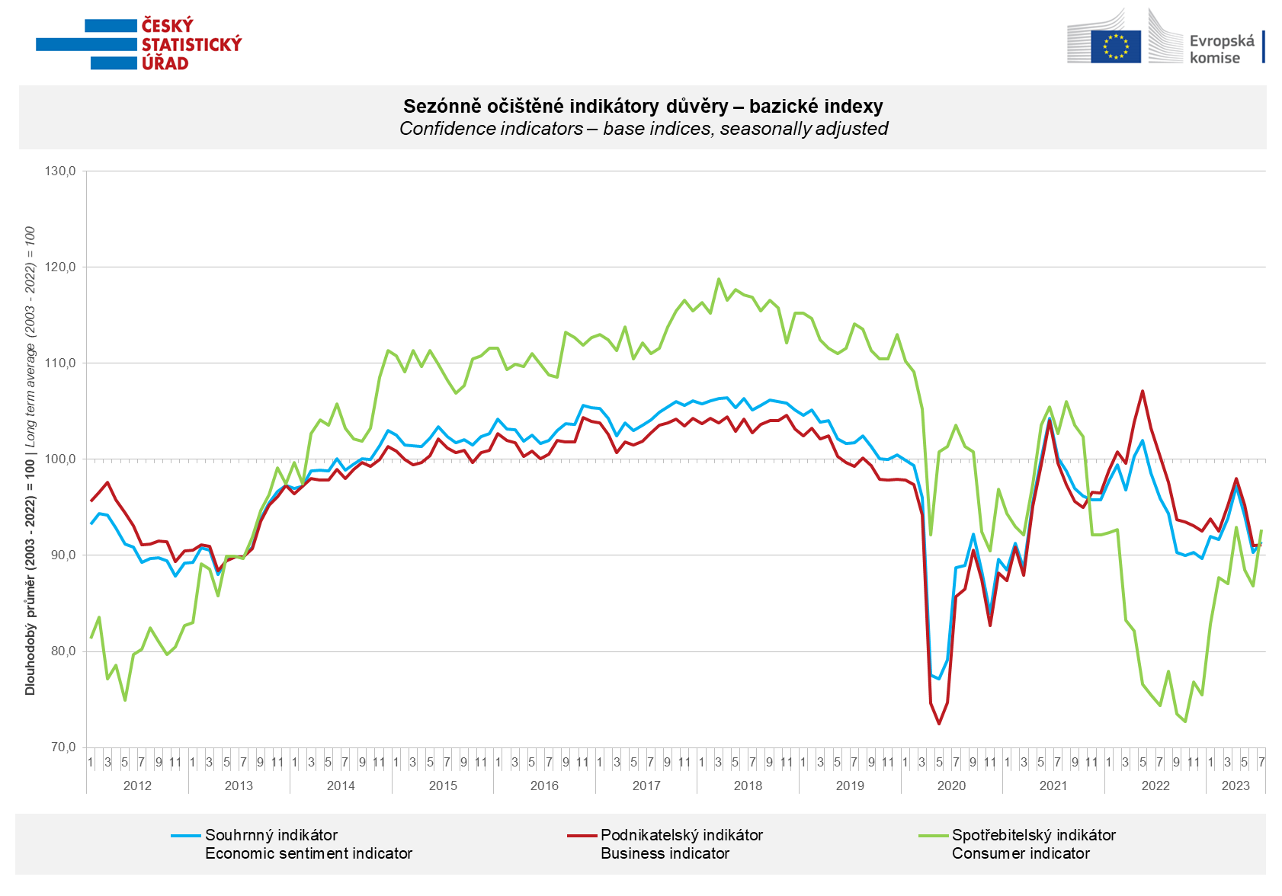

Among entrepreneurs, after a two-month decline, confidence in the economy increased in industry (+2.9 points) and trade (+1.7 points), while it decreased in selected services (-2.5 points) and in construction (-4. 2 points).

Consumer confidence in the economy increased m-o-m. The number of respondents expecting a deterioration of the overall economic situation in the Czech Republic in the next twelve months decreased. The number of households rating their current financial situation worse compared to the previous twelve months also decreased, and for the second time in a row, the number of households who fear a worsening of their own financial situation in the next twelve months also slightly decreased. The share of respondents who believe that the current time is not suitable for making large purchases has hardly m-o-m.

***
More detailed information on the development of business and consumer confidence can be found in the supplementary information to the RI business surveys.

Notes:

Responsible manager: Juraj Lojka, Director of Business Statistics Coordination and Business Cycle Surveys Department, tel. +420731439291, e-mail: juraj.lojka@czso.cz
Contact person: Jiri Obst, Head of Business Cycle Surveys Unit, tel. +420604815440, e-mail: jiri.obst@czso.cz
Data source: CZSO business survey, Data Collect consumer survey (https://www.datacollect.cz)
Data collection date: Business part: July 17, 2023
Consumer part: July 17, 2023
Next News Release: August 24, 2023

This press release wasn´t edited for language.

Detailed time series of Balances and basic
indices of confidence indicators: https://www.czso.cz/csu/czso/kpr_ts
Business and Consumers Surveys are co-financed by grant agreements of the European Commission DG ECFIN.
https://ec.europa.eu/info/business-economy-euro/indicators-statistics/economic-databases/business-and-consumer-surveys_en
Link to European database: https://ec.europa.eu/eurostat/web/euro-indicators/business-and-consumer surveys

Annex:
Additional information to NR Business cycle survey
Table Confidence Indicators – basic indices
Graph 1 Confidence indicators – base indices, seasonally adjusted (2003–2023)
Graph 2.1 Confidence Indicators for industry, construction, trade, and in selected services – base indices, seasonally adjusted (2003–2023)
Graph 2.2 Balances of seasonally adjusted confidence indicators for industry, construction, trade, and in selected services (2003–2023)
Graph 3 Economic Sentiment Indicators – international comparison, seasonally adjusted (2007-2023)
Graph 4 Production Capacity Utilisation in Manufacturing Industry (2003-2023)
Graph 5 Limits of Production in Industry (2005-2023)
Graph 6 Limits of Production in Construction (2005-2023)
Graph 7 Limits of Production in Selected Services (2005-2023)

