May 24, 2023

Consumer and business confidence in the economy decreased

Business cycle survey – May 2023
The composite confidence indicator (economic sentiment indicator) – in the basis index form – decreased by 3.1 points to 94.1 m-o-m, with the same developments of its components. The business confidence indicator decreased by 2.8 percentage points to 95.2 and the consumer confidence indicator decreased by 4.4 points to 94.1.
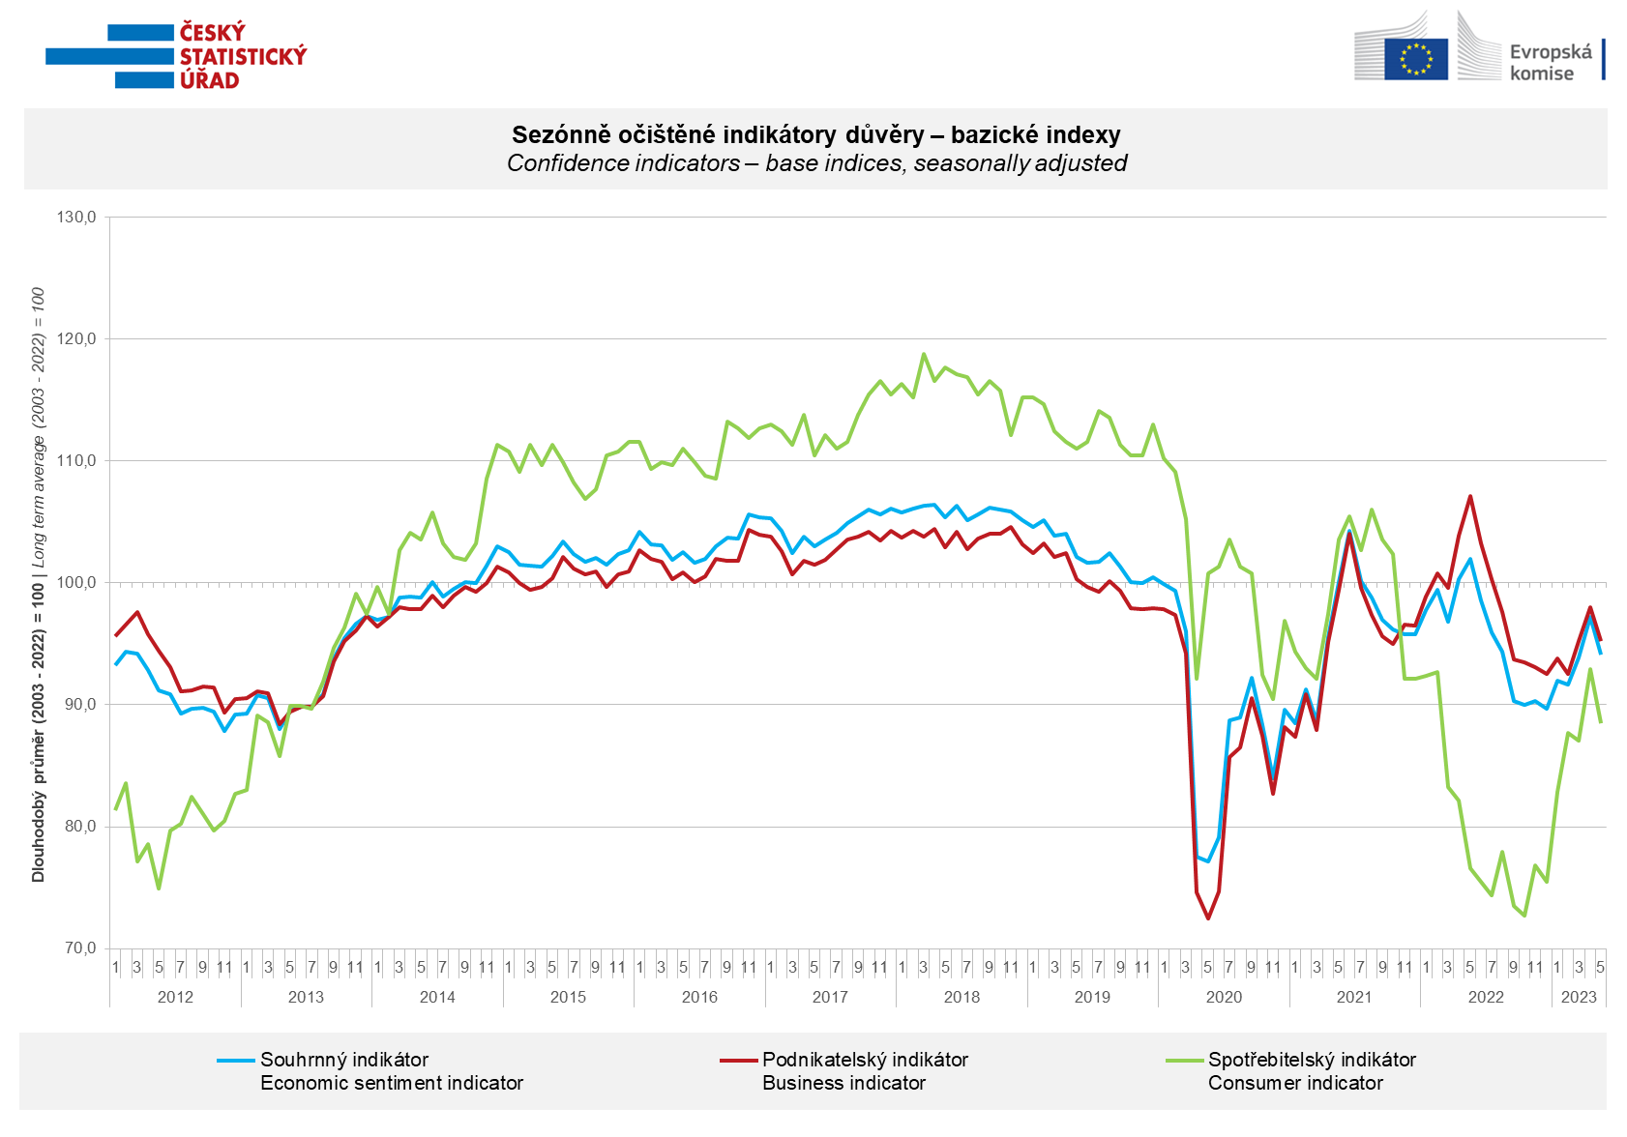

Confidence in the economy among entrepreneurs decreased significantly in May in industry
(-8.2 points) and to a lesser extent in trade (-2.3 points). It did not change in construction and in selected services it increased for the second time in a row (+2.3 points).

Consumer confidence in the economy decreased. Compared to April, households are significantly more worried about the deterioration of the overall economic situation and their own financial situation. They rate their current financial situation better compared to the previous twelve months. The share of respondents who believe that the current time is not suitable for making large purchases decreased slightly month-on-month.

***
More detailed information on the development of business and consumer confidence can be found in the supplementary information to the RI business surveys.

Notes:

Responsible manager: Juraj Lojka, Director of Business Statistics Coordination and Business Cycle Surveys Department, tel. +420731439291, e-mail: juraj.lojka@czso.cz
Contact person: Jiri Obst, Head of Business Cycle Surveys Unit, tel. +420604815440, e-mail: jiri.obst@czso.cz
Data source: CZSO business survey, Data Collect consumer survey (https://www.datacollect.cz)
Data collection date: Business part: May 18, 2023
Consumer part: May 15, 2023
Next News Release: June 26, 2023

This press release wasn´t edited for language.

Detailed time series of Balances and basic
indices of confidence indicators: https://www.czso.cz/csu/czso/kpr_ts
Business and Consumers Surveys are co-financed by grant agreements of the European Commission DG ECFIN.
https://ec.europa.eu/info/business-economy-euro/indicators-statistics/economic-databases/business-and-consumer-surveys_en
Link to European database: https://ec.europa.eu/eurostat/web/euro-indicators/business-and-consumer surveys

Annex:
Additional information to NR Business cycle survey
Table Confidence Indicators – basic indices
Graph 1 Confidence indicators – base indices, seasonally adjusted (2003–2023)
Graph 2.1 Confidence Indicators for industry, construction, trade, and in selected services – base indices, seasonally adjusted (2003–2023)
Graph 2.2 Balances of seasonally adjusted confidence indicators for industry, construction, trade, and in selected services (2003–2023)
Graph 3 Economic Sentiment Indicators – international comparison, seasonally adjusted (2007-2023)

