2 April 2024

General government sector balance ended up with a deficit in 2023

Notification of government deficit and debt – 2023

For the year 2023, the balance of the general government sector ended up with a deficit corresponding to 3.3% of the GDP, which is a year-on-year (y-o-y) increase by 0.1 percentage point (p. p.). The general government sector debt in the end of the year 2023 reached 44.0% of the GDP while the y-o-y decrease was by 0.2 p. p.

“The balance of the general government sector for the year 2023 ended up with a deficit in the amount of CZK 239.7 billion (bn); in the year-on-year comparison, expenditure on social benefits increased the most. The government debt ratio slightly decreased compared to the year 2022 and reached 44.0% of the GDP,” Helena Houžvičková, Director of the Government and Financial Accounts Department of the Czech Statistical Office (CZSO), stated.

The largest share in the deficit continued to belong to the balance of the central government sub-sector that ended up with the deficit of CZK 305.0 bn. The local government sector balance ended up with a surplus of CZK 70.3 bn and the social security funds sub-sector (of health insurance companies) ended up with a deficit of CZK 5.0 bn.

Table 1: Notification table of government deficit and debt, the Czech Republic, 2020–2023
 | Unit | Year
 |  | 2020 | 2021 | 2022 | 2023
Net borrowing/lending of general government | CZK mil. | -329 216 | -310 628 | -215 355 | -239 687
General government consolidated gross debt | CZK mil. | 2 149 822 | 2 566 731 | 2 997 615 | 3 228 367
Net borrowing/lending of general government as % of the GDP | % | -5.8 | -5.1 | -3.2 | -3.3
General government consolidated gross debt as % of the GDP | % | 37.7 | 42.0 | 44.2 | 44.0

During spring notifications, the general government sector balance for the year 2022 was also slightly revised; it improved by CZK 2.6 bn mainly owing to updating of data on taxes.

The total general government sector revenue increased in 2023 by 10.0%, y-o-y; in absolute terms, it was an increase by CZK 281.8 bn. Revenue from income taxes and from social contributions were increasing the most.

The total general government sector expenditure increased in 2023 by 10.1%, y-o-y, i.e. by CZK 306.2 bn. The highest increase was recorded for social benefits paid, subsidies, and compensation of employees paid.

In the end of 2023, the relative debt of the general government reached 44.0% of the GDP. In the year-on-year comparison, the relative debt decreased by 0.2 p. p. An increase in the nominal GDP contributed to the decrease of the relative amount of the debt (-3.4 p. p.), whereas the nominal growth of the debt contributed in relation to the GDP to an increase by 3.2 p. p.

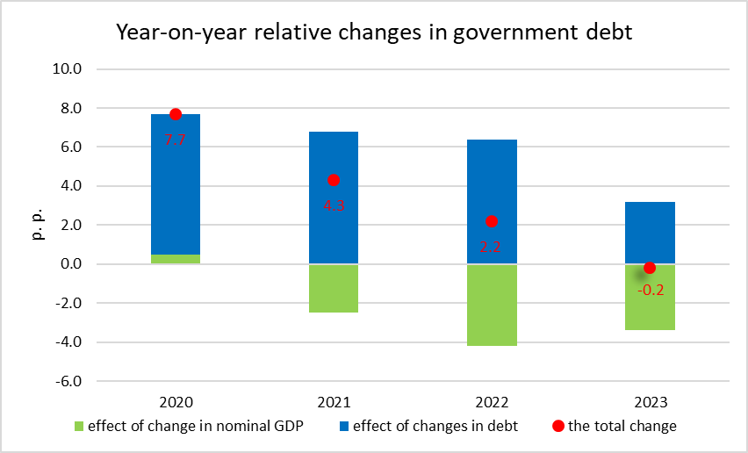

In the end of 2023, the general government debt reached CZK 3 228.4 bn; a major part of it consists of issued debt securities the volume of which increased by CZK 346.2 bn, y-o-y; on the other hand, there was a decrease in received loans (CZK -124.4 bn).

Indicators presented in the Table 1 were transmitted to Eurostat on 29 March 2024.
Notes:
Notification of government deficit and debt is compiled always for the past four years and submitted to the European Commission by each Member State of the European Union always at the end of March and September each year, including a projection for the current year. The projection for the current year is compiled and published by the Ministry of Finance of the Czech Republic. Quantification of fiscal indicators is based on the ESA 2010 methodology and serves the assessment of how the Maastricht convergence criteria are complied with. Pursuant to the Maastricht criteria, the government deficit must not exceed 3% of the GDP and the level of the accumulated government debt must not exceed 60% of the GDP.

Government surplus/deficit is represented by the item B.9 “net borrowing (−) or net lending (+)” in the system of national accounts. The indicator refers to the ability of the general government sector in the given year to finance other sectors of the economy (+) or the need of the general government sector to be financed (−) by other sectors.

The government debt consists of consolidated liabilities of the general government sector in the form of currency and deposits, issued debt securities, and received loans. In case of foreign exchange debt instruments hedged against currency risk, value in CZK is obtained by means of a contractual exchange rate.

Responsible head at the CZSO: | Helena Houžvičková, Director of the Government and Financial Accounts Department, phone: (+420) 704 688 734, e-mail: helena.houzvickova@czso.cz
Contact person: | Jaroslav Kahoun, Head of the Government Accounts Unit, phone: (+420) 274 054 232, e-mail: jaroslav.kahoun@czso.cz
Next news release will be published on: | 22 April 2024

